Using Microsoft Builder with 3D Slicer

Microsoft 3D Builder (MS Builder) is a software tool that allows you to alter 3D content so that it can be used for 3D printing. This can be useful for separating different components of a 3D model. Models are often used in 3D Slicer to provide visualization features. Thus, using MS Builder to prepare models for loading in 3D Slicer is an effective solution. Certain considerations must be taken when preparing models for 3D Slicer using MS Builder.

# File Formats:

* Ensure that all 3D models are in .stl (stereolithography) before loading into both 3D Builder and 3D Slicer
* If the 3D model is not in .stl format to begin with use online converters such as:

# Splicing Model in MS Builder:

1. Open model file in 3D Builder. Ensure that file’s units are mm, since 3D Slicer does measurements in mm.

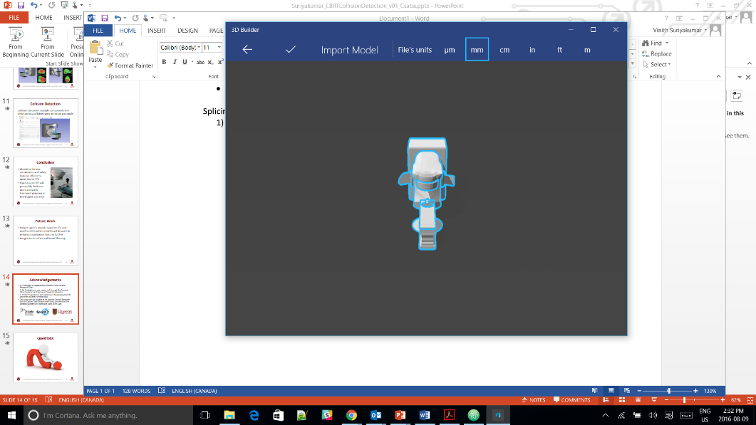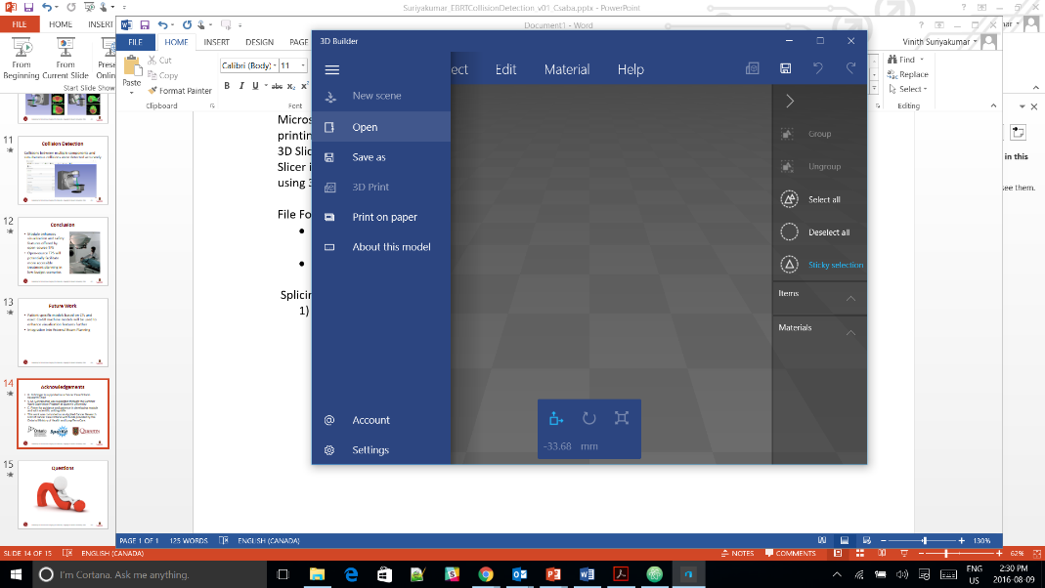

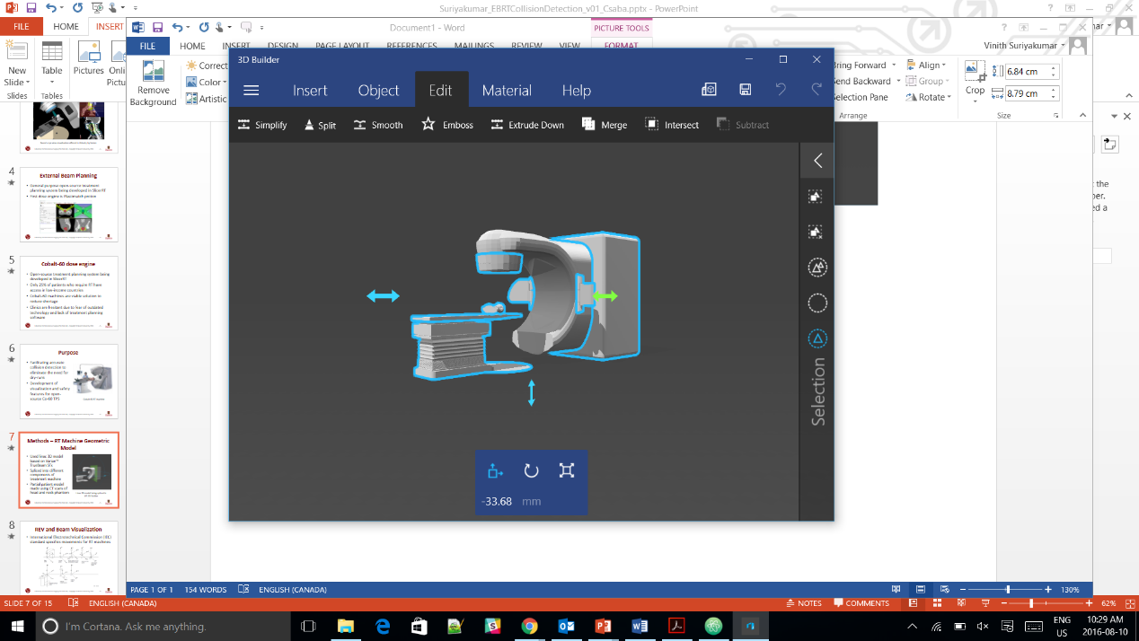

1. Click the Edit option in the toolbar and click the Split option.
2. 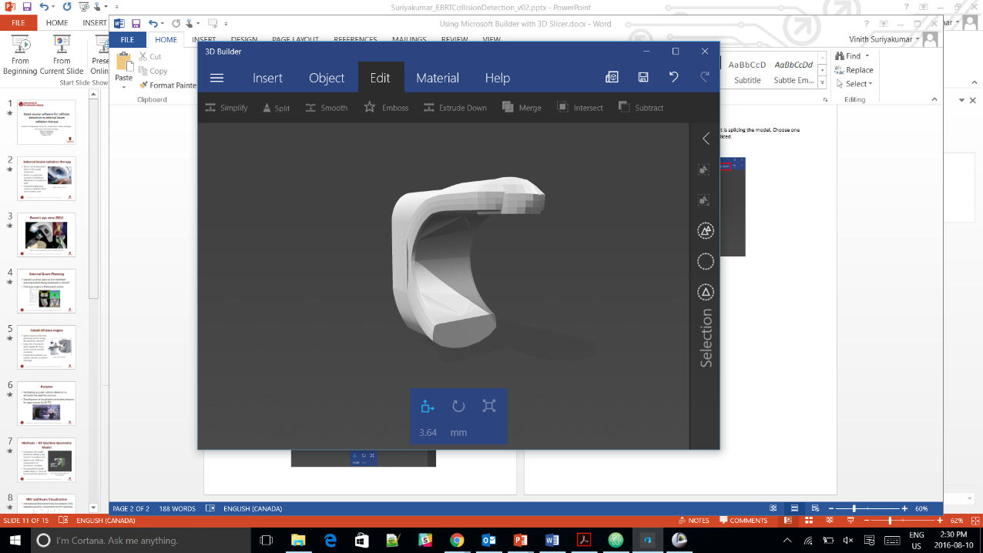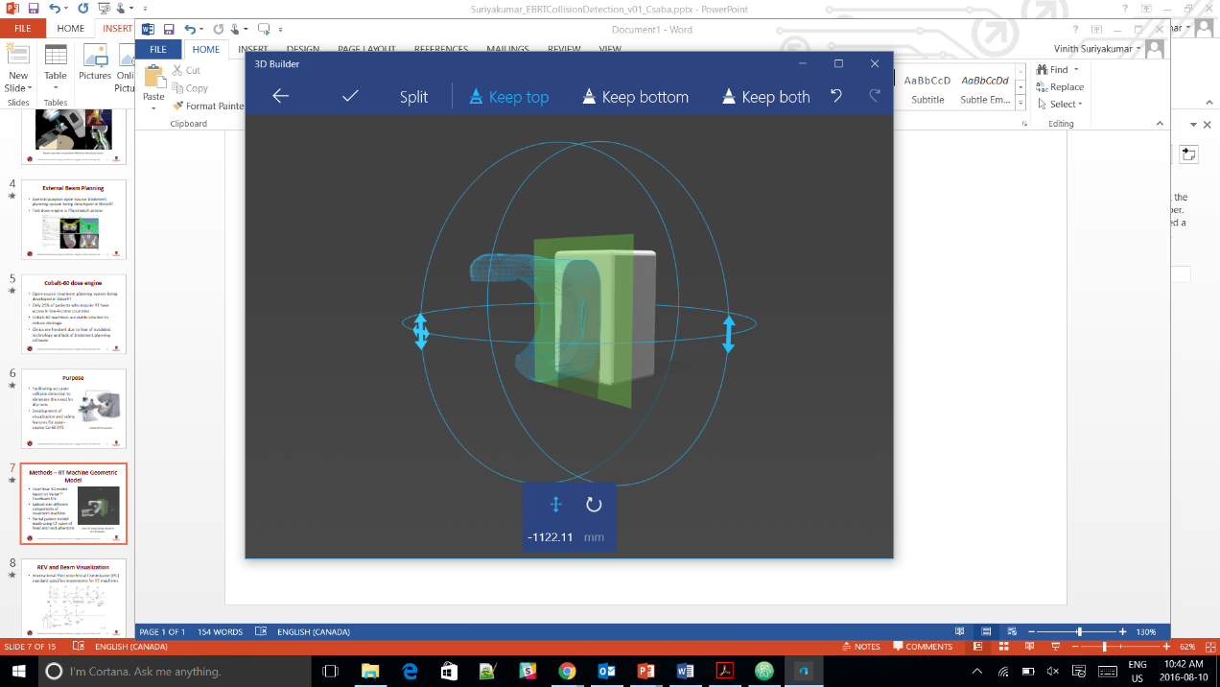Using the arrows on the circles, translate and rotate the plane that is splicing the model. Choose one of the options to decide which part of the model you want to be spliced.

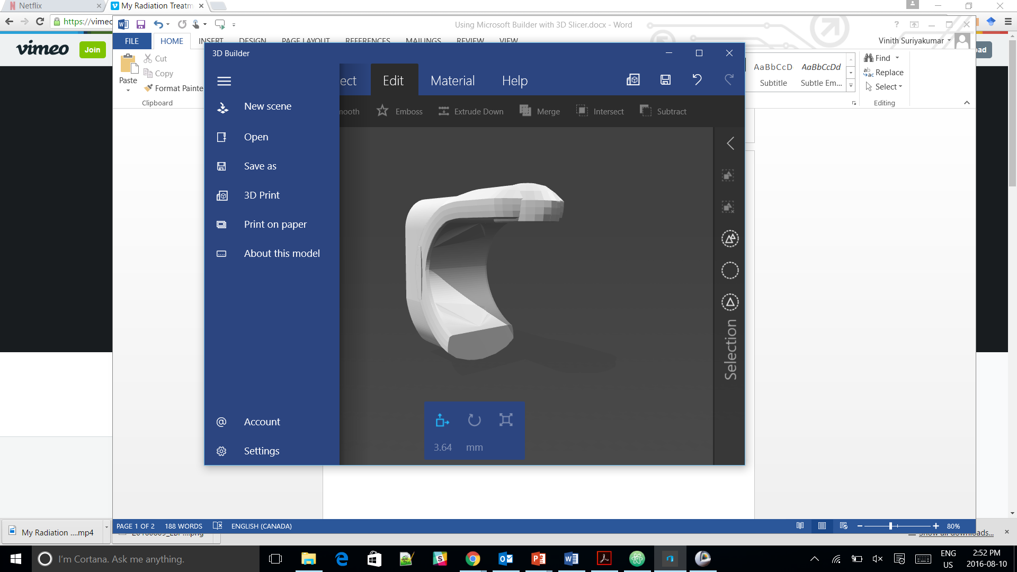

1. Save the model component as an .stl file.

# Loading Model in 3D Slicer:

1. Click on “Load Data” button in “Welcome to Slicer” module.
2. Click either “Choose Directory to Add” (if you have a folder with a series of models) or “Choose File(s) to Add” (if you only have one or two models).
3. Click “OK” button.

# Troubleshooting:

1. The textures and colors of my model are gone after converting the file to STL format?

Unfortunately, STL files do not store information about textures and colors of 3D models. They only store information about the surface geometry of an object. Thus, many times the STL format will look different than the original 3D model.

1. My models are not in the correct position when I load them in 3D Slicer?

MS Builder and 3D Slicer have different coordinate systems. Thus, translations and rotations done in MS Builder end up being completely different in 3D Slicer. Most of the time the only solution is to repeatedly do the translations and rotations in MS Builder and reload the models into 3D Slicer until the models are in the correct positions. This is only larger issue when you have several models that take specific positions to make up a larger model (Ex. Linear accelerator shown in previous images).